EX.NO: | EMPLOYEES DATA ANALYSIS TOOL USING THE PANDAS
DATE: / /2025
Create a data analysis tool using the Pandas library in Python. This tool should enable users to load datasets, perform various data manipulation and analysis tasks, and visualize the results. Utilize Pandas functions to read data from different file formats (e.g., CSV, Excel), clean and preprocess the data, calculate summary statistics, and generate visualizations (e.g., plots, histograms) to aid in data interpretation

SOURCE CODE:

import pandas as pd
import matplotlib.pyplot as plt
import seaborn as sns
import random
from sklearn.model_selection import train_test_split
from sklearn.linear_model import LinearRegression
from sklearn.metrics import mean_squared_error, r2_score
import os

sns.set()

def generate_sample_dataset():
print("\n No dataset found. Generating sample data (700 employees)...\n")
data = {
'EmployeeID': range(1, 701),
'Name': [f'Employee_{i}' for i in range(1, 701)],
'Department': random.choices(['HR', 'IT', 'Finance', 'Sales', 'Admin'], k=700),
'Salary': [random.randint(30000, 120000) for _ in range(700)],
'YearsExperience': [random.randint(1, 20) for _ in range(700)]
}
df = pd.DataFrame(data)
df.to_csv("generated_employees.csv", index=False)
print(" Sample dataset saved as 'generated_employees.csv'\n")
return df

def load_data():
file_path = input("Enter file path (press Enter to auto-generate sample dataset): ").strip()

if file_path == "":
return generate_sample_dataset()

try:
if os.path.exists(file_path):
if file_path.endswith('.csv'):
return pd.read_csv(file_path)
elif file_path.endswith(('.xlsx', '.xls')):
return pd.read_excel(file_path)
else:
print(" Unsupported file type. Auto-generating dataset...")
return generate_sample_dataset()
else:
print(" File not found. Auto-generating dataset...")
return generate_sample_dataset()

except Exception as e:
print(f" Error loading file: {e}")
return generate_sample_dataset()

def clean_data(df):
df = df.dropna().drop_duplicates()
return df

def analyze_data(df):
analysis = df.describe().T
analysis.to_csv("salary_analysis_report.csv")
print("\n Summary Statistics:\n", analysis)
print("\n Report exported as 'salary_analysis_report.csv'")
return analysis

def visualize_trend(df):
if 'YearsExperience' in df.columns and 'Salary' in df.columns:
plt.figure()
sns.scatterplot(x='YearsExperience', y='Salary', data=df)
sns.lineplot(x='YearsExperience', y='Salary', data=df)
plt.title("Salary Trend vs Years of Experience")
plt.show()
else:
print("⚠ Trend visualization skipped (missing data)")

def visualize_histogram(df):
if 'Salary' in df.columns:
plt.figure()
df['Salary'].hist(bins=20)
plt.title("Salary Distribution Histogram")
plt.xlabel("Salary")
plt.ylabel("Frequency")
plt.show()
else:
print("⚠ Histogram skipped: No 'Salary' column found")

def predictive_model(df):
if 'Salary' not in df.columns or 'YearsExperience' not in df.columns:
print("⚠ Prediction skipped: Required columns missing")
return

X = df[['YearsExperience']]
y = df['Salary']

X_train, X_test, y_train, y_test = train_test_split(X, y, test_size=0.2, random_state=42)
model = LinearRegression()
model.fit(X_train, y_train)
predictions = model.predict(X_test)

print("\n Salary Prediction Performance:")
print("MSE:", mean_squared_error(y_test, predictions))
print("R2 Score:", r2_score(y_test, predictions))

plt.figure()
plt.scatter(y_test, predictions)
plt.xlabel("Actual Salary")
plt.ylabel("Predicted Salary")
plt.title("Actual vs Predicted Salary")
plt.show()

def main():
print("\n---- EMPLOYEE SALARY DATA ANALYSIS TOOL (ADVANCED) ----\n")
df = load_data()

print("\n Data Preview:\n", df.head())

df = clean_data(df)
analyze_data(df)
visualize_trend(df)
visualize_histogram(df) # <-- Added here
predictive_model(df)

print("\n Analysis Completed Successfully!")

if __name__ == "__main__":
main()

OUTPUT:

---- EMPLOYEE SALARY DATA ANALYSIS TOOL (ADVANCED) ----

Enter file path (press Enter to auto-generate sample dataset):

No dataset found. Generating sample data (700 employees)...

Sample dataset saved as 'generated_employees.csv'

Data Preview:
EmployeeID Name Department Salary YearsExperience
0 1 Employee_1 Sales 78392 6
1 2 Employee_2 Finance 59926 8
2 3 Employee_3 Admin 83040 10
3 4 Employee_4 Sales 68837 5
4 5 Employee_5 IT 113746 16

Summary Statistics:
count mean std min 25% \
EmployeeID 700.0 350.500000 202.216880 1.0 175.75
Salary 700.0 72853.258571 25405.976817 30175.0 51116.75
YearsExperience 700.0 10.504286 5.667843 1.0 6.00

50% 75% max
EmployeeID 350.5 525.25 700.0
Salary 72444.0 94080.00 119975.0
YearsExperience 10.0 16.00 20.0

Report exported as 'salary_analysis_report.csv'
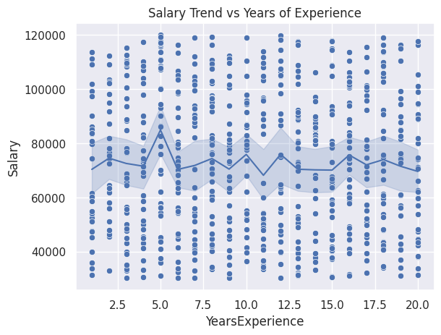
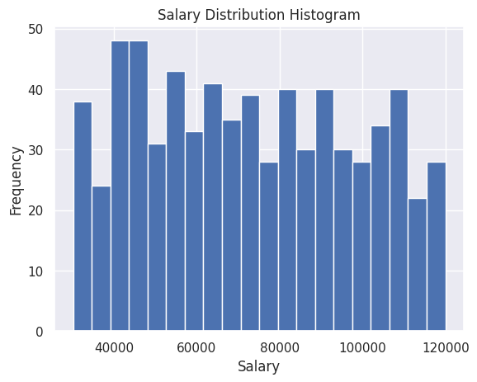
Salary Prediction Performance:
MSE: 648232825.9017441
R2 Score: -0.015900229786927955
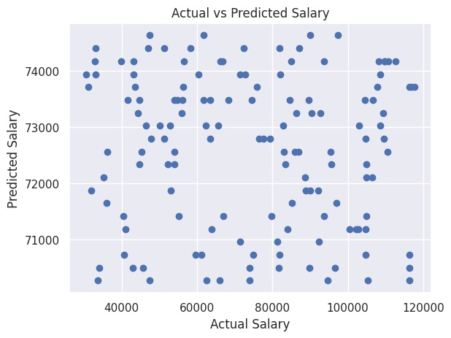
✔ Analysis Completed Successfully!

